Gedion Kiprotich

C025-01-0624/2020

A Photographic Essay on Important Rites of Passage in African Communities.

My essay will explore the significant rites of passage within African culture, including:

1. Birth
2. Naming
3. Circumcision
4. Marriage
5. Death

BIRTH

Birth is a crucial rite of passage, signifying the introduction of a new member to the community and carrying profound cultural and communal meaning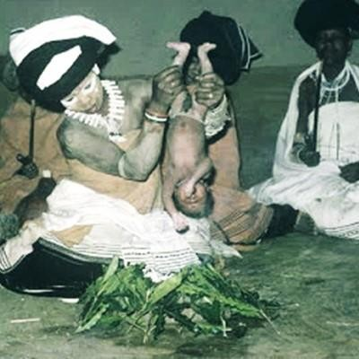

It consists of:

**Symbolic transformation**: A new baby signifies a transformation for the family, the community, and the individual themselves. It represents life's continuance, the continuation of a family's heritage, and the expansion of a community.  
**Naming Tradition**: In many African societies, naming ceremonies are customs commonly connected to childbirth. Elders or community leaders frequently choose a name for a kid during the naming process, taking into account a variety of variables such as the child's birth circumstances, family history, or anticipated traits for the child's future.

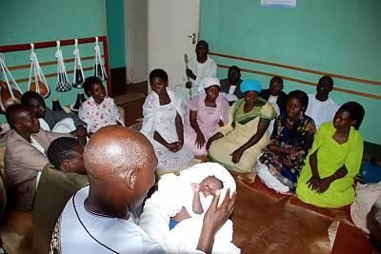

**Celebration of the New Life:** The birth of a child is a communal event that unites friends, family, and the larger community. The engagement of the community shows shared accountability for the child's upbringing and welfare.

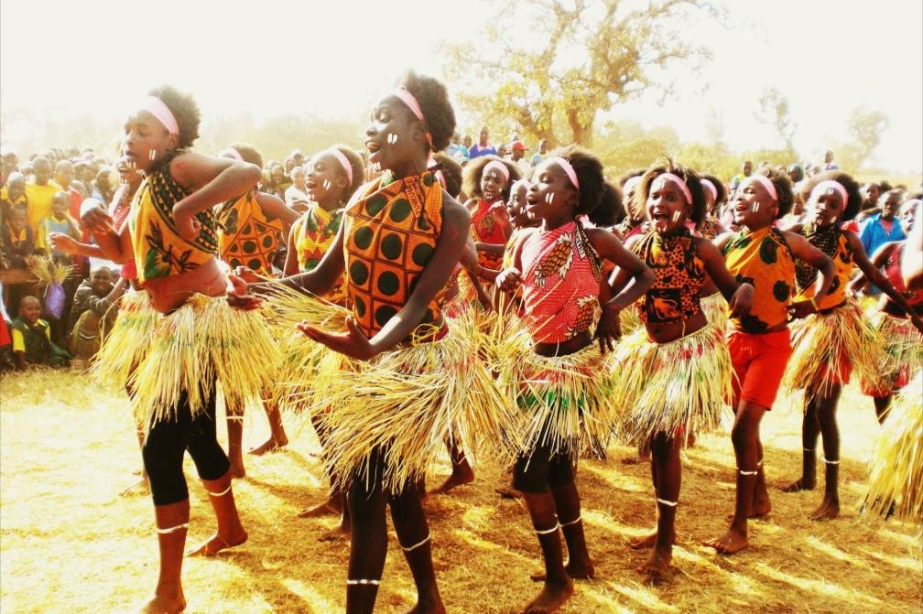

* 1. **CIRCUMCISION**

Male circumcision is highly valued in many African communities on a social, cultural, and occasionally religious level. There are significant differences in the customs, beliefs, and motivations for circumcision among the many ethnic groups and geographical areas.This is an account of circumcision in an African context:

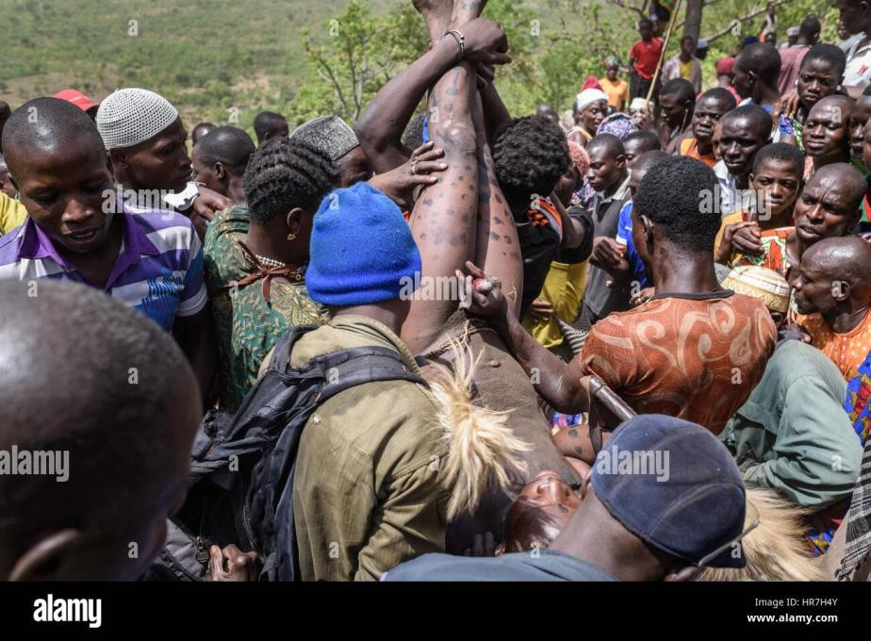

CulturalSignificance:

**Rite of Passage:** The marking of the passage from boyhood to manhood is frequently circumcision.It's an important milestone that denotes bravery, maturity, and preparation for taking on adult responsibilities within the community.

**Cultural Identity:** Cultural identity is closely linked to circumcision. It provides a means for people to participate in cultural customs and ceremonies and to be acknowledged as complete members of their community.   
Customs and Traditions:

**Ceremonial Preparation**: There may be a period of preparation before to the circumcision ceremony, which includes lessons on obligations as well as customary songs, dances, and rituals intended to give the initiates wisdom and courage.

**Ceremony**: The actual circumcision ceremony is frequently a community gathering. The circumcision is typically performed by elders or traditional healers in a private or sacred setting. The process is carried out with conventional instruments and methods.

**Healing and Seclusion:** Following the circumcision, the initiates are isolated for a while to recuperate, during which they receive instruction regarding their roles as males in the   
  
cultural norms, ethics, and community

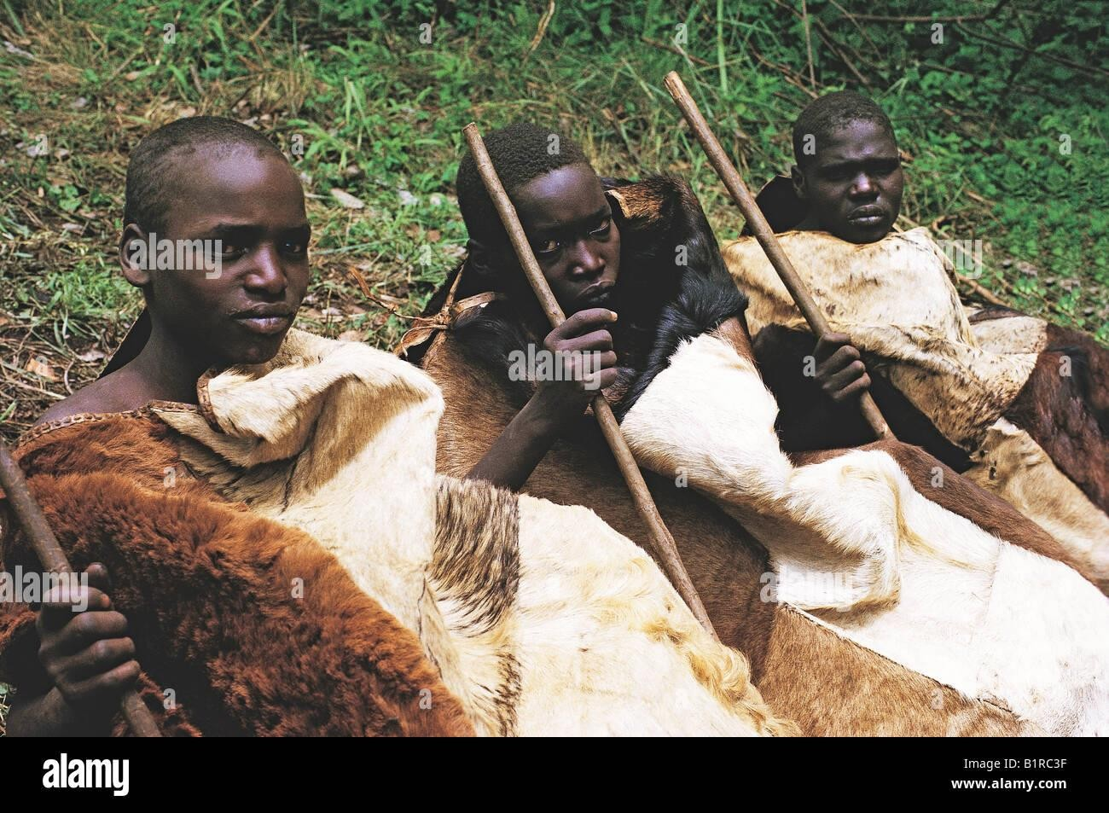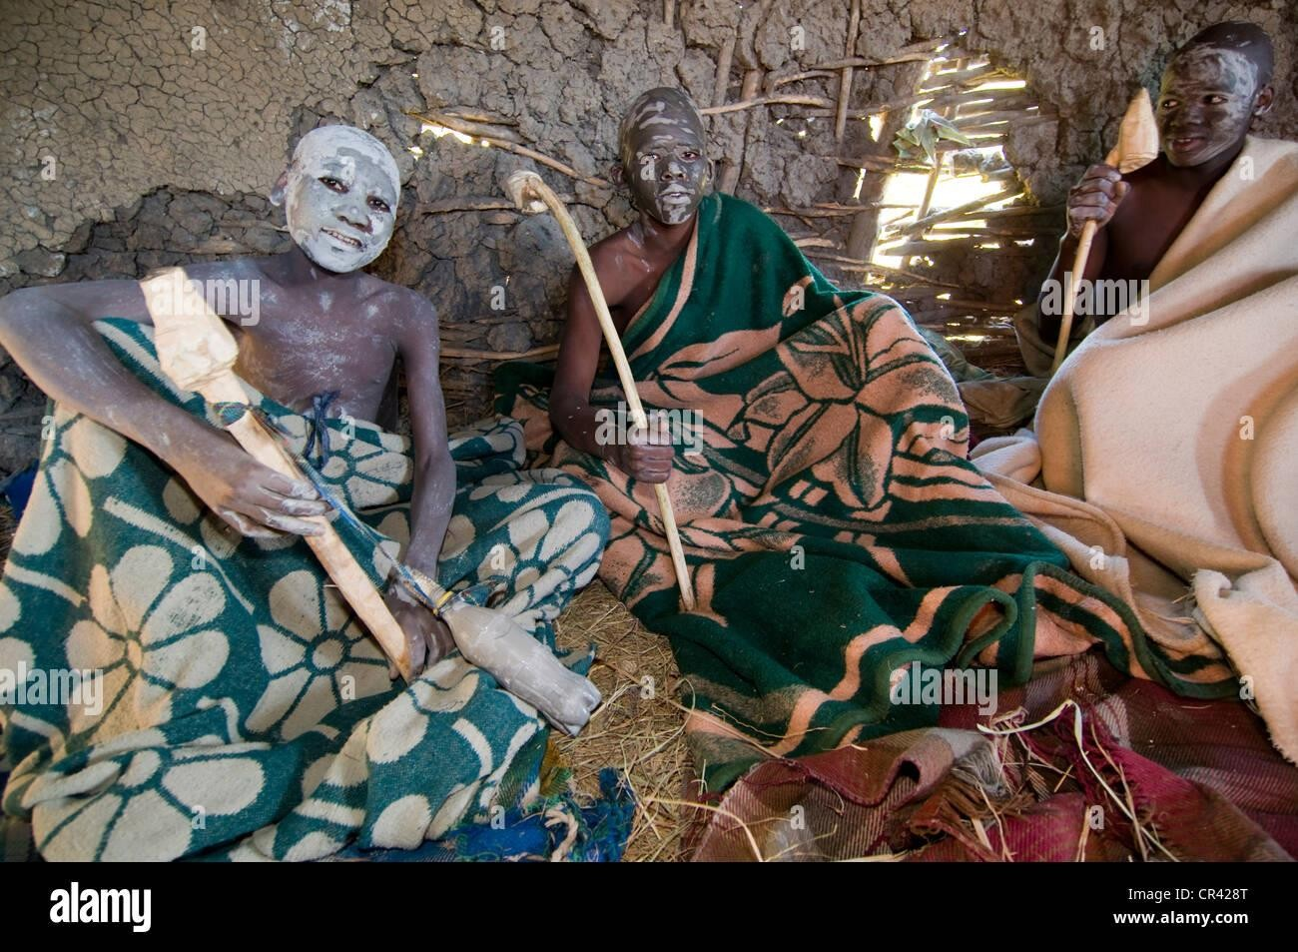

Social andHealthAspects:

**Social Integration**: After completing the initiation and healing process successfully, the initiates are accepted back into society as men. They can now get married and assume a variety of social obligations.

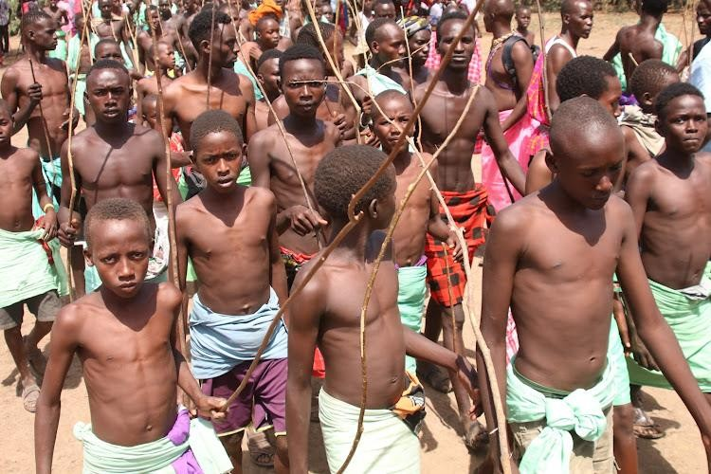

**Health Considerations:** Although the main motivations for circumcision are frequently cultural and traditional rather than strictly medical, it is frequently thought that the procedure has health benefits, such as cleanliness and protection against specific diseases.

* 1. MARRIAGE

In many African countries, marriage is deeply culturally significant because it represents the union of families and communities. It symbolizes a social relationship that extends beyond a union between individuals and involves widespread family participation and customary rites.

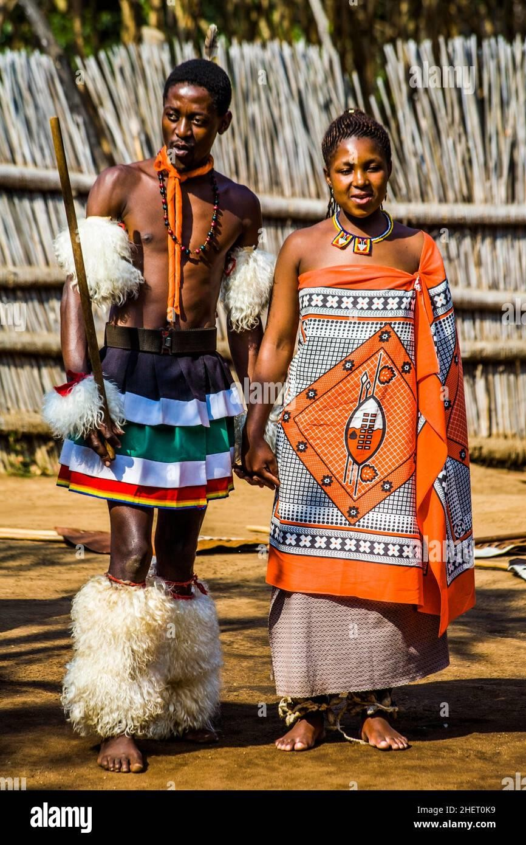

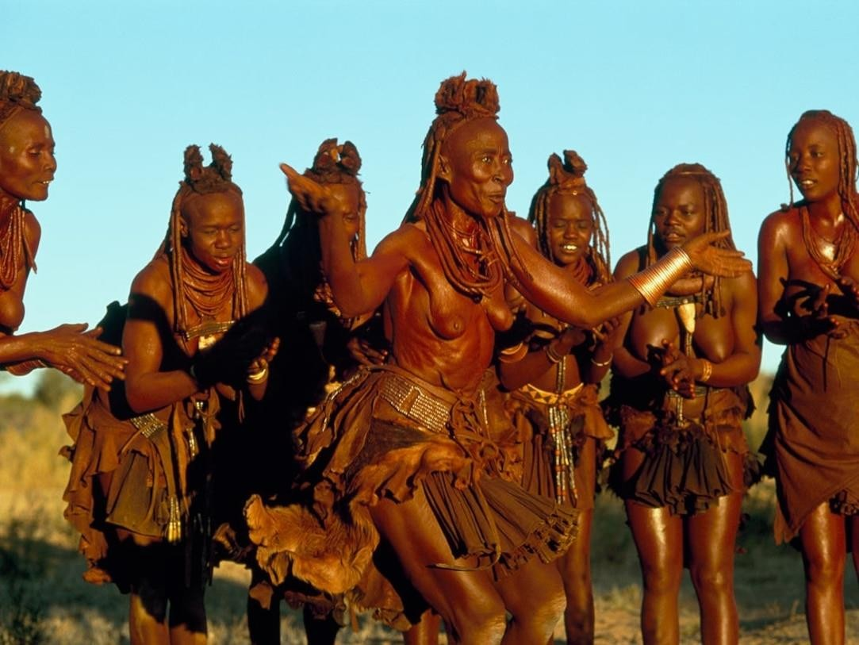

Marriage ceremonies are colorful and varied in African cultures; they include dances, rituals, and symbolic actions that emphasize harmony and respect local customs.These rituals frequently entail financial transactions, such dowries, which stand for reciprocal respect and acknowledgment amongst families.In communities, marriage is essential for fostering social cohesiveness and stability because it creates support systems and bonds amongst families. It also carries with it the preservation of cultural customs, gender norms, and community involvement.

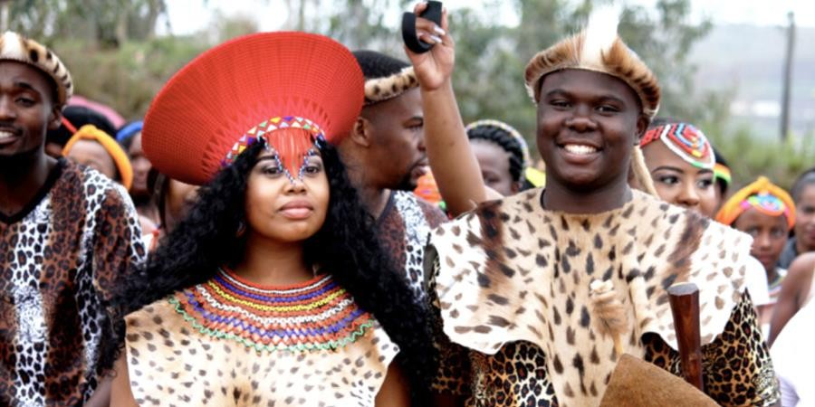

African marriage practices are based in tradition, although they change with time to accommodate contemporary forces like globalization. Marriage continues to be essential to familial relationships, societal bonds, and the preservation of cultural legacy throughout the continent, notwithstanding changes.

* 1. Death

This is the sole part of the rite that is associated with loss and sadness, and it is recognized as a crucial part that is characterized by rites and rituals that pay tribute to the deceased and help them make their transfer to the afterlife.

**Rituals and Traditions**: African civilizations range greatly in their death rites, which may involve particular rites, prayers, and customs carried out by   
  
religious leaders or community members.

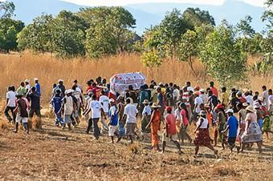

**Mourning Period**: Families may observe a period of mourning, during which they pay respect to the departed by engaging in rituals, dressing in particular ways, and abstaining from particular activities.

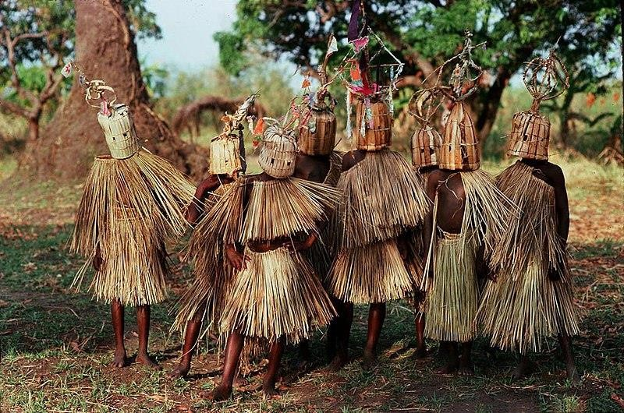

**Communal Support**: The community is essential in helping the grieving family by offering support and aid. To console the family, get-togethers, shared meals, and condolence messages could be made.